- Go to: http://fsi.fanta.de/index.php/snippet#
- Click on: 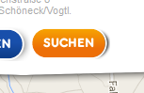
- Click here: 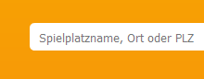
- And put in „15537“ -> 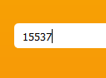
- Click on the right side on: 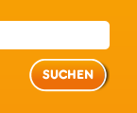
- This appears on the left side: 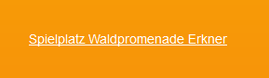
- Click on it.
- Click on „Abstimmen“ 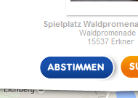
- LogIn with your FacebookAccount:
- Or Login with your existing Account: 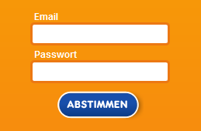 and press „Abstimmen“
- or create a new FantaAccount: 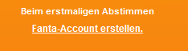
- Therefore put in 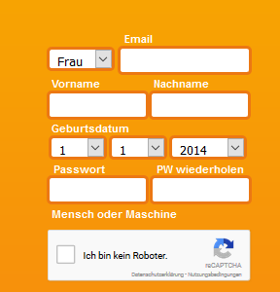 your Data.
Frau = Woman, Mann = Man; Email; Vorname = prename; nachname = fullname; Geburtsdatum = Birthdate; passwort = pasword; PW wiederholen = Password repeat.
- Click both checkboxes: 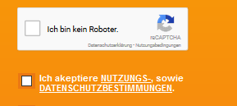
- An click here
- Done.
- Next day you use your EMailadress and password in number 10.

